**OBJECT ORIENTED PROGRAMMING LAB**

**Name: Sanio Luke Sebastian**

**Roll No: 35**

**Batch: B**

**Date: 24-04-2022**

**Lab Cycle No.: 2**

**Aim**

1. Program to Sort strings
2. Search an element in an array.
3. Perform string manipulations
4. Program to create a class for Employee having attributes eNo, eName eSalary. Read nemploy information and Search for an employee given eNo, using the concept of Array ofObjects.

**Procedure & Outputs**

1. **SortStrings.java**

import java.util.*;

public class SortStrings {

public static void main(String[] args){

String names[] = { "Avil","Sharon","Vishnu","Vijay","Sammy","Nebin","Tejas","Aakash","Besanio" };

System.out.println("The names' order before sorting : ");

for (int i = 0; i < names.length; i++)

System.out.println(names[i]);

Arrays.sort(names);

System.out.println("\nThe names in alphabetical order : ");

for (int i = 0; i < names.length; i++)

System.out.println(names[i]);

}

}

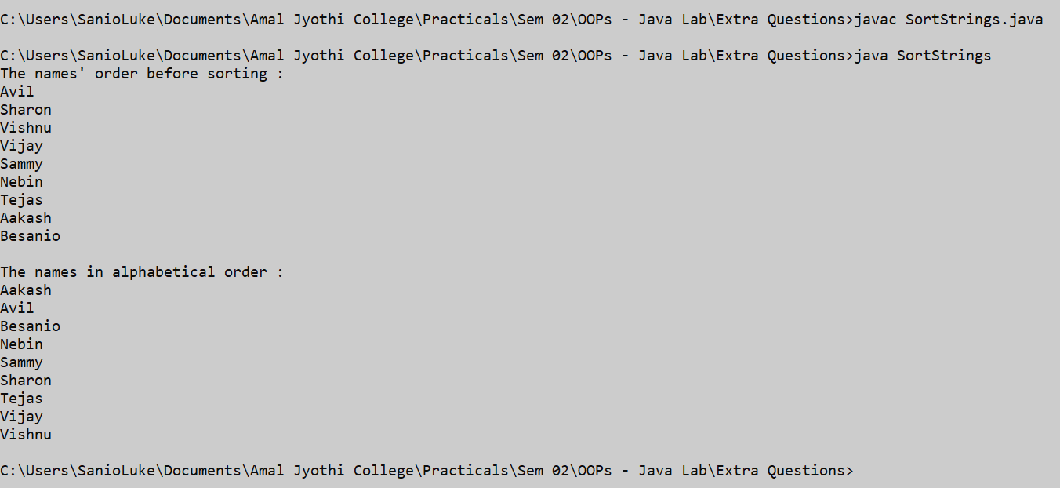

1. **ArraySearch.java**

import java.util.*;

class ArraySearch{

private boolean search(int[] arr, int item){

boolean isfound=false;

for(int i=0;i<arr.length;i++){

if(item==arr[i]){

isfound=true;

break;

}

}

return isfound;

}

public static void main(String[] args){

Scanner sc= new Scanner(System.in);

ArraySearch inst= new ArraySearch();

int size, search_item;

System.out.print("Enter the size for the array : ");

size= sc.nextInt();

int[] arr= new int[size];

System.out.println("\nPlease enter the elements for the array : ");

for(int i=0;i<size;i++)

arr[i]= sc.nextInt();

System.out.print("Please the item that you want to search : ");

search_item= sc.nextInt();

String res= inst.search(arr, search_item) ? "is found / available." : "is not found / not available";

System.out.println("The searched item i.e. "+search_item+" "+ res);

sc.close();

}

}

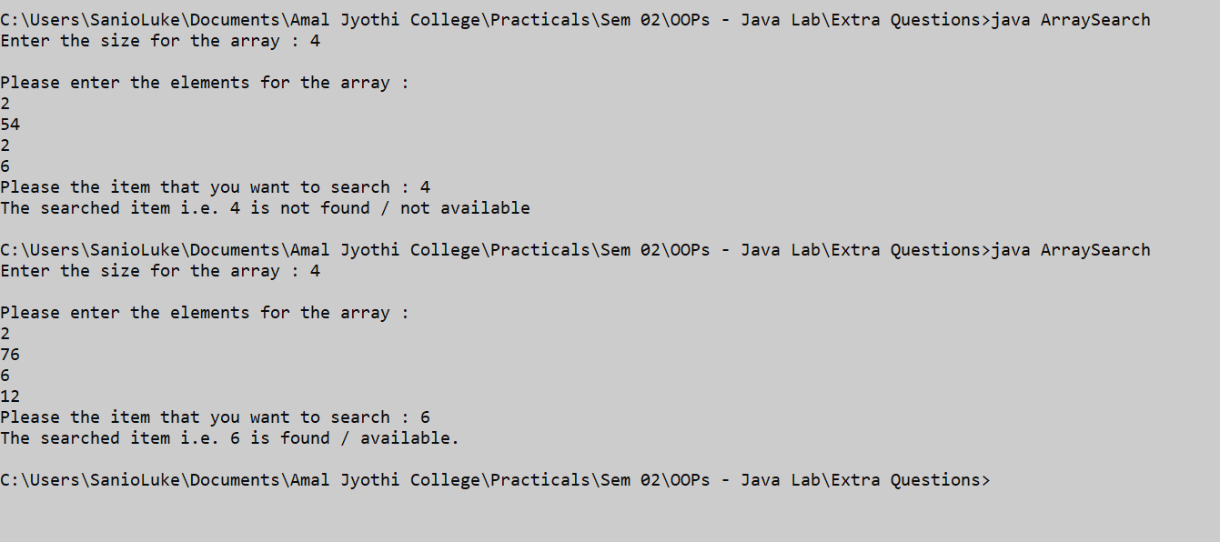

1. **StringManipulation.java**

public class StringManipulation {

public static void main(String[] args){

String str1= "This is my first job ", str2="and I like it.";

System.out.println("The string 01 is : "+str1+"\nString 02 is : "+str2);

String strconcat= str1+str2;

System.out.println("\nThe concatenation of two strings is : "+strconcat);

String strUppercase= str1.toUpperCase();

System.out.println("\nNormal String to uppercase string is : "+strUppercase);

String strLowercase= str2.toLowerCase();

System.out.println("\nNormal String to lowercase string is : "+strLowercase);

String strsubString= str1.substring(5);

System.out.println("\nSubstring of the string is : "+strsubString);

String strtrim= str1.trim();

System.out.println("\nString trim is given by : "+strtrim);

boolean strcontains= str1.contains("my");

System.out.println("\nCheck if the string 01 contains -'my' : "+strcontains);

int strlength= str2.length();

System.out.println("\nThe length of the string 02 is : "+strlength);

}

}

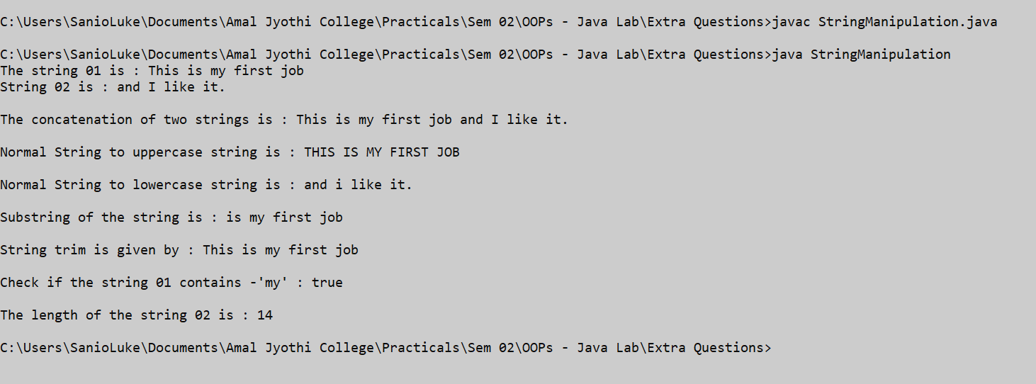

1. **ArrayObjects.java**

import java.util.*;

class Employee{

int eno, esalary;

String ename;

Employee(){ }

Employee(int eno, String ename, int esalary){

this.eno= eno;

this.ename= ename;

this.esalary= esalary;

}

}

public class ArrayObjects {

private boolean searchEmp(Employee[] arr, int sempno){

boolean isfound= false;

for(int i=0;i<arr.length;i++){

if(sempno==arr[i].eno){

isfound=true;

break;

}

}

return isfound;

}

public static void main(String[] args){

int size, search_emp;

Scanner sc= new Scanner(System.in);

System.out.print("Enter the number of employees that you want to list : ");

size= sc.nextInt();

Employee[] emps= new Employee[size];

for(int i=0;i<size;i++){

Employee emp= new Employee();

System.out.print("Enter the number for the employee "+(i+1)+": ");

emp.eno= sc.nextInt();

System.out.print("Enter the name for the employee "+(i+1)+": ");

emp.ename= sc.next();

System.out.print("Enter the salary for the employee "+(i+1)+": ");

emp.esalary= sc.nextInt();

emps[i]= emp;

System.out.println("\n");

}

System.out.print("Enter the emp no of the employee that you want to search : ");

search_emp= sc.nextInt();

ArrayObjects inst= new ArrayObjects();

String res= inst.searchEmp(emps, search_emp) ? " is found / available." : " is not found / not available";

System.out.println("The searched employee with the emp no "+search_emp+res);

sc.close();

}

}

